Paper Title (use style: paper title)
Subtitle as needed (paper subtitle)

Authors Name/s per 1st Affiliation (Author)
Dept. name of organization (Line 1 of Affiliation - optional)
Name of organization - acronyms acceptable (line 2)
City, Country (line 3)
name@xyz.com – optional (line 4)
Authors Name/s per 2nd Affiliation (Author)
Dept. name of organization (Line 1 of Affiliation - optional)
Name of organization - acronyms acceptable (line 2)
City, Country (line 3)
name@xyz.com – optional (line 4)

With the proliferation of smart electronic devices and exploding data creation and demand by their users, there are ongrowing unresolved issues such as unreliable latency, lack of mobility support, location-awareness and network bandwidth. This is the reason for shifting the cloud to the extreme edge to the things that produce and act on the data. This is known as “Fog Computing”. With manufacturing costs of smart devices plummeting, it is easier than ever to create small devices with embedded sensors to create, collect and exchange data. Fog computing could be used in reducing the burden of Cloud by bringing the resources such as storage, compute and networking between these devices and the cloud. But these ubiquitously connected devices are facing new security and privacy challenges. Security and privacy are one of the biggest challenges faced by Fog Computing. This survey highlights the potential security issues and challenges of fog computing like Authentication, Secure Data Storage, Secure Computations, Data and Usage privacy. This survey also provides solutions for the issues like Security through encryption, Adaptive Fog Computing Node Security Profile (AFCNSP) and security solutions like IOx.

Key Words—Fog Computing, Cloud Computing, IoT, Fog Computing security

Introduction to Fog Computing
Fog Computing is a new paradigm which shifts the cloud computing along with all its services to the edge of the network near to the devices. Offering the same set of services just like the cloud computing, fog computing could be used to alleviate the shortcomings of the cloud computing in the coming future. Cloud computing will be susceptible to low quality service given the present paradigm of storing, analyzing and processing all the data in the cloud which is very far away from the device, which is generating that data. This is where the Fog computing comes into picture. With the decentralization of computing infrastructure in such a way that data analysis, computation and data processing are distributed in much more efficient way between the point of data creation, device and the cloud. By doing this, Fog computing brings all the advantages and capabilities of cloud to the device which is on edge of the network where the data is being created.

Need for Fog Computing
The concept of Cloud is centralizing data to the cloud and to do the storage, processing and computing in the cloud. Cisco IBSG predicts there will be 50 billion IoT devices till the end of 2020. With the near future having so many devices interconnected to one another or better known as the IoT, there will be a lot of scalability problems. Those devices will also generate huge amount of data. As per GE report, a jet engine produces Gigabytes of data every hour which needs to be processed. These examples show us that it will be challenging for cloud computing to handle these requirements. Cloud computing can be a severe bottleneck in a lot of perspectives like latency, network bandwidth, reliability, security, mobility and vast geographical diversity. All of these problems could be addressed and alleviated by Fog computing. With the help of Fog computing we can decentralize these service cluster and data, and can provide, to some extent, these services closer to the client who is at the edge of the network. Since not all the data will cross the local network there will less hops, which will in turn reduce the latency. With the devices being in the same network the data storage and data analytics will be done on the correct level on the network. 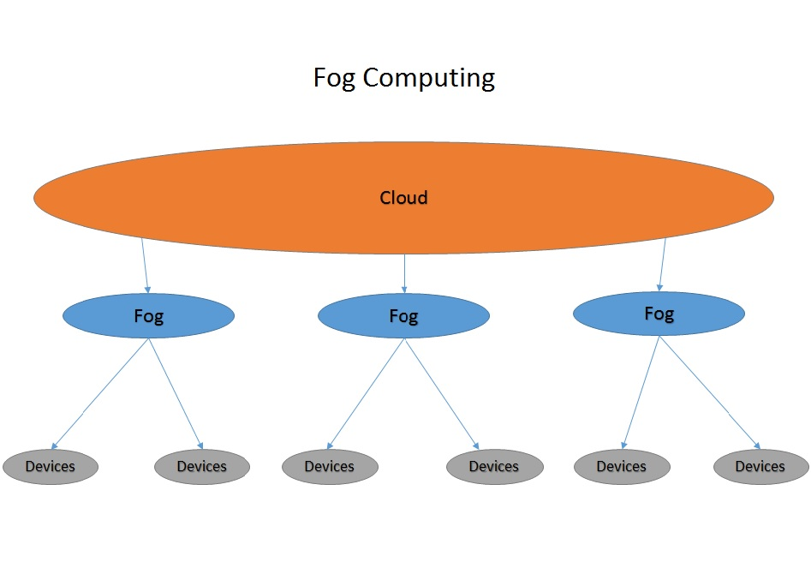
Figure 1. Fog Computing Paradigm

Fog Computing with IoT
In 2013, the Global Standards Initiative on Internet of Things (IoT-GSI) defined the IoT as "the infrastructure of the information society.” [1] It is basically the internetworking of all the smart devices which are connected to the network. With billions of devices to be connected the fog computing can provide a platform for these devices to use the optimum bandwidth and utilize the latency which previously could not be possible in the cloud computing.

Structure of the survey
This survey is about understanding the security challenges of the Fog computing. There are various challenges in the security of the Fog computing which are to be resolved. Also, in conjunction with IoT fog computing is certainly the next step in cloud technologies. We talk about the security issues and their potential solutions. We also talk about the solutions already provided in industry like the Cisco IOx.

Security issues and Challenges
Use of new technology (Fog cloud) leads to the rise of new security and privacy issues. The security of the existing Fog computing system is less secure making the system vulnerable. This section identifies and examines the security and privacy issues of Fog computing.
The users are going to rely only on those which take preventive measures to protect the system. There are various factors like authentication, authorization, network, availability, storage etc. which influences the security and privacy of Fog computing system. Identifying these issues and the extent to which they are affecting the system will help in improving the quality of service provided to the users and making the system more resistant from the attackers.
As fog inherits the basic abilities of cloud, it also inherits the issues of cloud but as in fog computing the devices work on the edge of the network, these issues are unlike in nature. This section inaugurates the significance of security and privacy in Fog computing by focusing on privacy, authentication, gateway and data issues.

Privacy Issues
Protecting private information in fog computing is a big challenge as it is inherited from cloud computing. Information privacy is the capability to maintain the private information of a user or an organization. In fog computing the data generated from the devices are sent to the closest fog network. To process a huge volume of data Fog divides the data into chunks. The best solution for this issue could be encrypting and decrypting the data, but due to less number of resources, the IoT device lacks the capability of encrypting and decrypting the data. So, after processing, the data is combined or integrated where the integrity within the data should be verified.
Another privacy issue can be usage, which can give the information of when the user is using an IoT device letting attacker to know the pattern of the presence and absence of the user at a place which completely violates the privacy of the user. Usage pattern can also reveal the various information like when the user is using what type of devices, when the user is not using any devices and the study of this usage pattern can allow the attacker to know when the user is not at home breaching the privacy of the user.
Also as the fog server moves the data to the closest fog node, so the fog node has the information of the client using its resource. This can easily give the information of the location to the attacker breaching the Location privacy of the client. Similarly, if the user uses the fog services at different locations daily, it will reveal the attacker the pattern in which the user travels causing risk to the user.
The above-mentioned privacy issues can be solved using various mechanisms such as homomorphic encryption for data privacy, create dummy tasks for usage privacy, selecting the fog node on basis of some criteria like load balance or latency, instead of the closest node. One of the Privacy preserving mechanism of Data, Usage and Location privacy is explained Yi Shanhe in [1]

Authentication issues
The increase in the number of devices using fog technology will lead to the need of authentication of services and resources in fog computing. User should be prohibited to access the system based on the permission level provided to the user, otherwise it may cause the breach of authentication. Use of biological distinct features like biometric such as finger print scanner, voice recognition, face recognition technique can be considered as the way to identify the actual owner or the person who has access to a specific module [1]. The system can also use different authentication factors like Knowledge factor which will allow the user to access system based on the username and its password or pin, Inherence factor in which the authentication includes asking answer to questions as added by the user at the time of registration, Possession factor allows the user to access the system based on some security token possessed by them.

Gateway Issues
Fog devices which are working as the gateways can be easily cloned and can be exchanged with the cloned device. This process of cloning and exchanging the gateway with the cloned one is known as Man-in-the-middle attack.
The attacker can take the control of the system by connecting client to the malicious device or point. This type of attack consumes very little CPU consumption causing very hard to detect the attack without any distinct observation. [2] Examines how stealthy the man-in-the-middle attack is with the example of communication between 3rd generation users and wireless LAN users and explains the workflow of the attack. The man-in-middle attack can be detected using 2 steps. The first step is adding malign code and the next step is to refresh the ROM or add a counterfeit active point in the domain. The two methods are easy to implement and can help in detecting the man-in-middle attack.

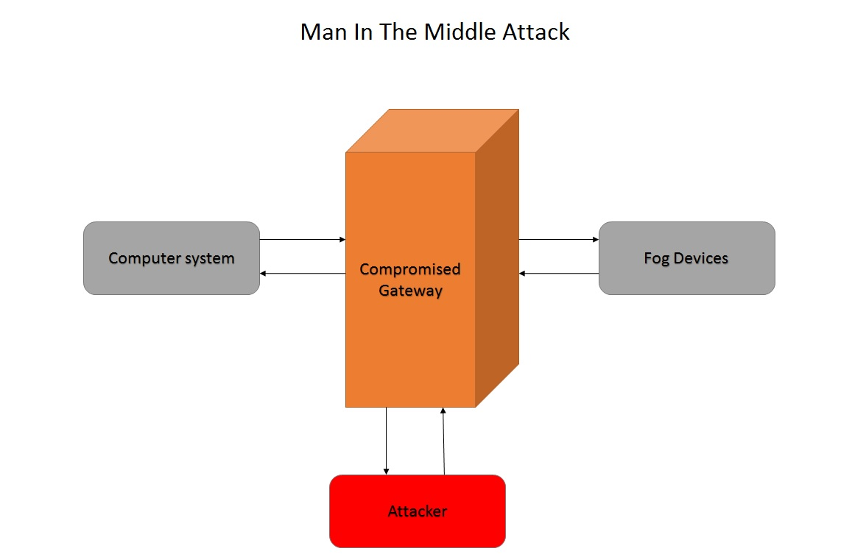
Figure 2. Man In The Middle Attack

Data Issues
As the data in fog computing is stored in third party environment, the security of the data becomes one of the important issue of the fog computing. Cryptography can form as the basis for storage of data which can used as technique to keep the stored data secure. Moreover, in fog computing data is managed using distributed protocols which makes it difficult to identify the hacked file [3]. It is also difficult to identify whether data to be stored is correct and not modified. Even the data that is uploaded can be misused by unapproved user. Searchable or homomorphic encryption can be used to verify the data from doubtful server.

Existing Security Solutions for Fog Computing
Fog Computing is one of the most and newest promising models for service providers, fog providers and users. It is similar to cloud computing but has characteristics which are more distinct. It introduces multiple Fog devices between users and the Cloud. Other than the already existing issues in cloud, fog experiences new security and privacy challenges. These issues need to be addressed. There have been many proposals put forward to tackle the security issues in Fog computing.
In this chapter, we survey in brief, few of the proposed and existing solutions to address security and privacy issues in fog computing.

Offensive Decoy Technology
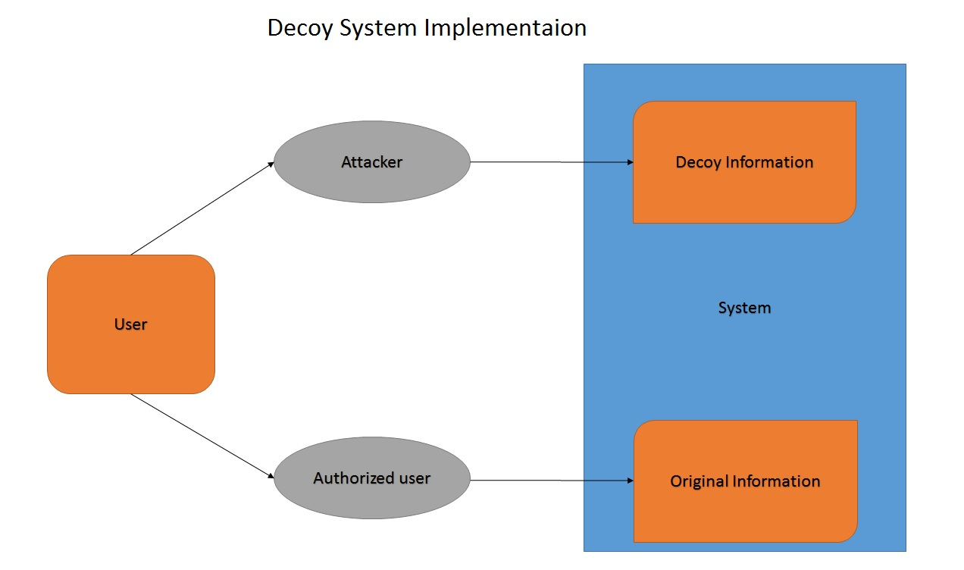
Figure 3. Offensive Decoy Technology
Increasingly many businesses, startups are opting for outsourcing data and computation to Cloud which is aimed at improving the efficiency and overall business productivity. But opting cloud also means increasing the risks of misusing sensitive data. The data should be available to be accessed only by the respective customer whenever needed. Storing the customer’s data in a safe storage and protecting it is main security concern in cloud. One of the most serious concern of security issues related to data are data theft attacks. The intensity of risk increases if the attacker is an insider. The lack of transparency in such cases, makes the system further vulnerable to data thefts attacks.
Stolfo, Salem and Keromytis [4] propose a new approach for securing data to protect against data theft attack. Their model is based on combination of two technologies: offensive decoy technology and user behavior profiling. Combining the two technologies makes the system more reliable and relatively resistant against data thefts.
In offensive decoy technology, the system provides false files along with sensitive files names for instance; social security number, pin details, credit cards detail etc. which are provided by the service provider. These dummy files are intended to trick the attacker into believing these files are original. There are chances that the attacker will be tricked into clicking the files to download them. As soon as the attacker tries to download the files, an alert is raised and the system will become aware of the possible attack on the data. This method is combined with user behavior profiling to make the system more efficient to prevent the data theft attacks.
User behavior profiling is a method which will alert the system of any suspicious and unauthorized access. Every time the data is accessed, the cloud is designed to monitor and detect any abnormal pattern in accessing the data. A disinformation attack is launched if illegitimate access is suspected and then confirmed using security queries. Disinformation attack is sending back loads of false information to the attacker so that user’s real data is safe and protected. Disinformation attacks are targeted to be used against malicious insiders and it prevents them from differentiating between the real sensitive data of the customer and fake valueless data.
If the user is mistaken as the attacker and is sent with false documents, the user can differentiate between the original and the fake data. The user can contact the services, prove he is authentic user and hence gain access to his original files.
Combining the two techniques i.e. decoy technology and user behavior profile technology, improves the systems detection accuracy and makes it more efficient in preventing data thefts.

Intrusion Detection
Intrusion detection system is a procedure which a system for signs of any harmful/malicious activities. If any such activities are detected, it is reported to the system admin or gathered in a system called SIEM or system information and event management. Any detected activity or violation is typically reported either to an administrator or collected centrally using a security information and event management. This system is responsible for distinguishing actual malicious attack from false alarms.
Intrusion detection system can be implemented in fog computing to detect malicious attack by analysis, monitoring and inspection of the user information, access control policy and log files at the fog node [5]. They can also be deployed at the fog network side to detect malicious attacks such as attack on the hypervisor and VM, port scanning, denial of service (DoS), Distributed denial of service (DDoS), etc. But the detection of rootkits is rather challenging due the scarce nature of resources any IoT device usually have. Also, an attacker can exploit any vulnerability to gain the kernel level access in a particular operating system.

Stand-alone authentication
Stand-Alone Authentication SAA is a new technique pioneered by the researchers to verify the authentication in unsteady connectivity conditions. Although to select SAA, there arises another issue to protect the information linking the users and the fog devices. But the SAA has some limitations. The basic approach to share data while keeping it secure is usually encryption. But in the case of fog computing, the efficiency of Public Key Infrastructure based authentication is not good enough. This is due to that fact that in Fog computing, the big dynamic systems are used. The common example is smart grid. In smart grid, there are huge number of Fog devices which are responsible for serving different locations. The access to these Fog devices may differ due to budget or different roles. For example, a person can have SAA only with Fog devices of Type X or Type Y in whole area. On the other hand, some other person can have SAA with Fog devices of all types but in a different area than the first person. As a solution to this, a new method called Attribute-based Encryption is adapted.

Adaptive Fog Computing Node Security Profile

A fog node is a structure of physical object equipped with electronic parts like sensors, internet connections, through which data is collected and distributed.
Eugen Petac and Andrea Petac [3] provide a solution to address security issues in fog computing. The proposal named Adaptive Fog Computing Node Security Profile (AFCNSP) is based on security Linux solutions. It is important for fog node to decide what security protection are necessary. Without proper authorization, a fog node cannot access the network, services and other application. Some of the Linux security models are Simplified Mandatory Access Control Kernel – SMACK (Schaufler, 2016), Discretionary Access Control – DAC (Schneider, 2016), Cynara (Tizen, 2016) and netfilter (Gheorghe, 2006) which protect data and process interactions from malicious manipulation by using a set access control rules. The functional requirements in AFCNSP include security services such as Authentication, Authorization, and Accounting (AAA); Mandatory, Discretionary, Role and Rule Based Access Control; Symmetric and Asymmetric Encryption; Data Integrity; Audit. AFCNS provides the required security services to process administrative, private, and sensitive pieces of data. These tools can prevent future attacks and help identify the parts of the system which are no longer trustworthy. AFCNSP is based on: Virtual Private Network connections, Secure Socket Layer/ Transport Layer Security certificates, Secure Shell authentication, firewalls, Service auditing, File Auditing, Intrusion Prevention System, Intrusion Detection Systems security solutions to protect the node.

Ciphertext-policy attribute-based encryption
Fog devices face unstable connectivity to distant Cloud for distributing authentication information and collecting audit logs. This property of weak and fragile connectivity in Fog Computing degrades the reliability of performing an authentication. Stomenovic et al.[2] introduced a new mechanism to address this problem by adapting to the unstable connectivity situation. The solution is based on Authentication (SAA) and combine it with Attribute-based encryption (ABE). The users right to access are, a set of attributes linking to his/her private key. But if a user can create new private key out of his right of access, this will violate the access control policy. This makes the system less preferred and this property in ABE systems is referred to as “key delegation abuse”.
This problem of key delegation abuse is addressed by [6] Jiang et al. They propose Ciphertext-Policy Attribute-based Encryption(CP-ABE) systems which is aimed at protecting against key-delegation abuse security issue. ABE allows one to many encryptions. In Ciphertext-Policy Attribute-based Encryption, a cipher text is encrypted with access policy. Whereas private key is related with the users set of attributes corresponding to the private key which satisfies the access policy. The basic rule in CP-ABE is that the user is not allowed to illegally create new private keys using subset of user’s attributes set.
The proposed model deploys bilinear groups property. Then, private key components are created based on two different group elements sets. Subsequently, the secret sharing scheme is applied on all attributes so that the key is not split or be combined with other private keys. Additionally, this system provides a scheme to get a traceable CP-ABE scheme, where the traitors are traced back efficiently.

Existing security service solutions and technologies for fog clouds

Fog computing is still in its nascent stage in the industry and therefore holds a lot of potential in the research in the security field. Although, Cisco has already come up with its security solutions for the fog computing and its integration with IoT with IOx.

Cisco solutions
IOx is technology developed by Cisco, implemented in edge network devices to smoothly introduce the services and application on multiple and different hardware platforms. IOx also hosts services and application in cloud providing reliability and security to the applications and thereby to client.

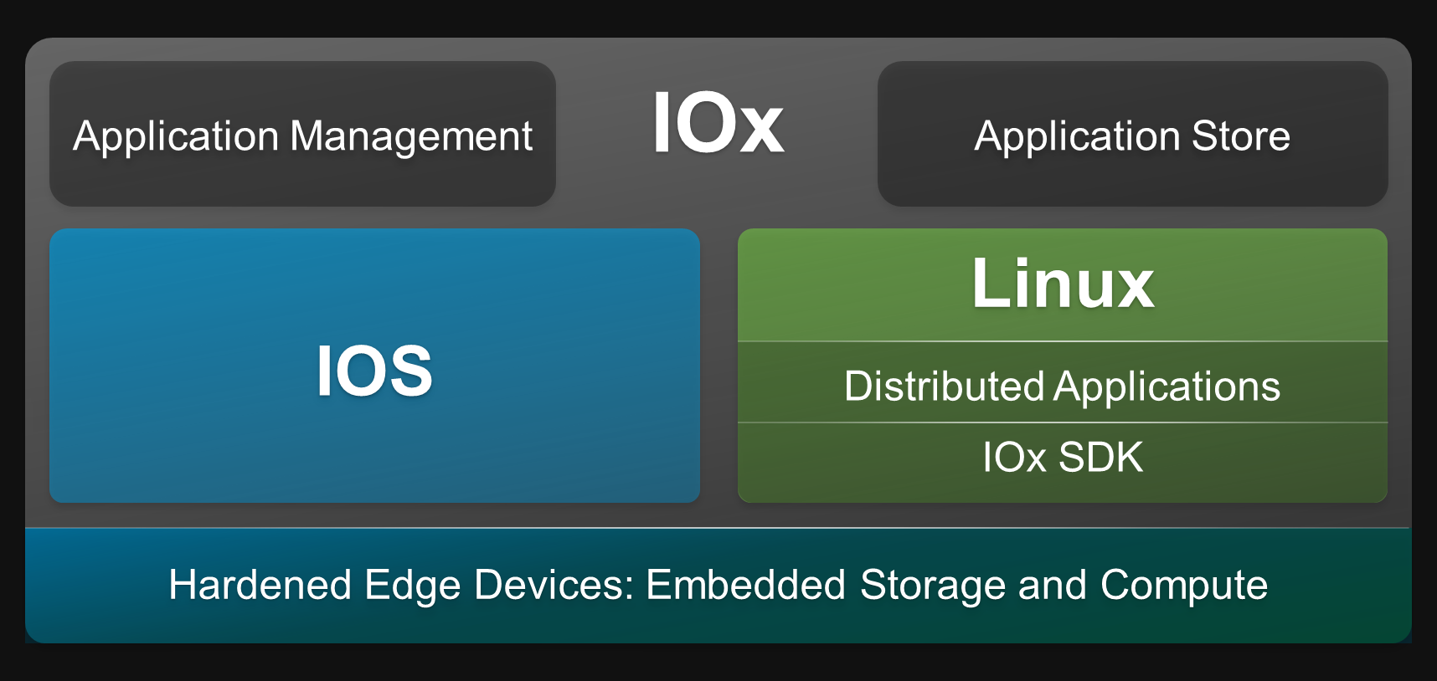
Figure No. 4 IOx platform by CISCO

It gives the ability to program various network devices like the servers, routers, access point servers which are connected to the Cisco fog node. These devices are not pre-configured from the factory and so it gives user has the ability to program it anyway. The sole objective of IOx is hosting applications in an operating system which is called a Guest Operating System or GOS. This guest operating system will run in a hypervisor directly over the Connected Grid Router also known as the CGR. This allows the execution of precompiled code the edge of the network. From factory, the Connected Grid Router comes with the Linux operating system (Yocto Linux) but if the user wants to change the operating system, it could be done easily by replacing that image of operating system with some other of user’s choice. With the help of this, the development and improvement of IoT applications is possible on the cloud itself. After this the deployment is possible to run in the cloud and the fog. This allows the same application to run on various types of fog nodes but with no alterations or modifications being required.
The client data could be protected using Cisco Cybersecurity solutions (Cisco, 2016) when it is transferring from the Fog Node to the cloud. This security could be provided to save the user’s data from the attacks. For example, any suspicious behavior could be identified with the help of Cisco NetFlow, Cisco TrustSec, and Cisco ISE. Security breaches could be avoided by the use of Cisco Advanced Malware Protection.

Cisco IOx components
The application environment provided by the Cisco IOx combines the execution of the applications in the fog with secure connectivity by the help of Cisco IOS software. So basically, Cisco IOx is a combination of Cisco IOS and Linux OS for a highly secure networking. The components of the IOx are as follows: -
- Cisco IOX – This provides the capability to host the Fog applications across throughout the connected infrastructure. This combines the IOS, and the Linux operating system for a greater security.
- Fog Director – Cisco Fog Director helps the administrators with the management, administration, monitoring and troubleshooting the applications which are running on the Cisco IOx environment.
- SDK and development tools – Cisco IOx SDK is a cluster of tools which could be used in assisting the developer in packaging their applications for their execution in the network infrastructure
- Fog Applications – Fog applications which are fit for their execution in the network infrastructure may be supplied by partners or can be developed with the common programming languages.

IOx architecture

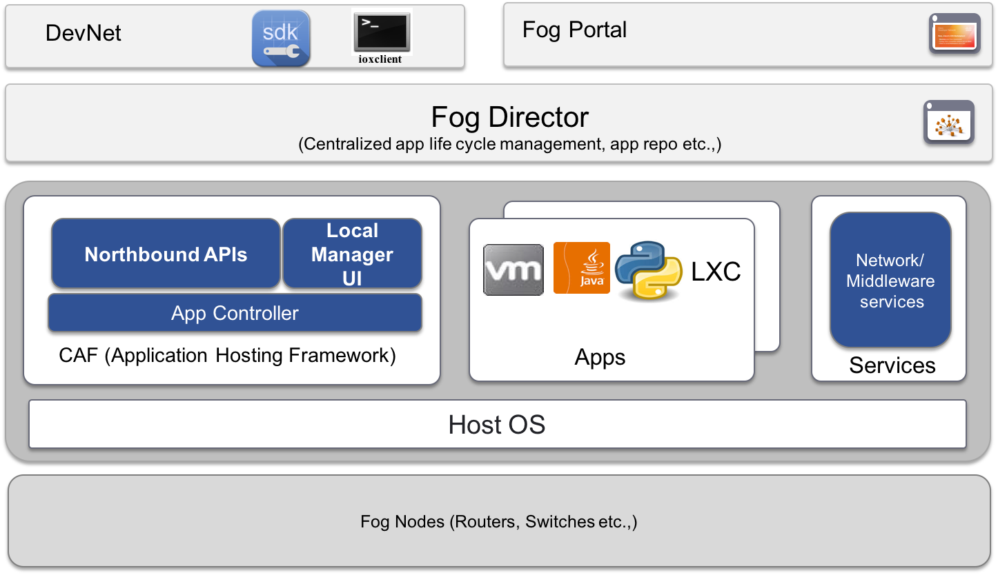
Figure 5. Cisco IOx Architecture

In the architecture, fog nodes supply the data generated in the real time by the device for the application. CAF is Cisco application hosting framework which performs the various important tasks such managing lifecycle of application, resources, monitoring, troubleshooting, logs, debugging etc. on fog nodes. The IOx middleware services is responsible for the entire system level details of the application. The core of the architecture is App where the main logic to be implemented on the fog node resides. Various types of applications are supported by IOx technology making the system dynamic in nature. Director of fog is responsible for managing the lifecycle and services provided to various devices. IOx software development kit is installed by the CAF which provides framework and packages on IOx platform sand connections, through which data is collected and distributed.
Some examples of the IOx enabled infrastructure are as follows: -
- Cisco 800 Series Integrated Services Routers
- Cisco 800 Series Industrial Integrated Services Routers
- Cisco Industrial Ethernet 4000 family of switches
- Compute Module for Cisco 1000 Series Connected Grid Routers

Conclusion
The fog computing architecture is the latest model for the service providers. But the usage of this service model in an appropriate way the security issues needs to be taken into consideration. The data theft attack are on the rise. Given the rise of the attacks, the data security issue is very serious. This survey report enlightens the various aspects of the security issues in the Fog computing. With the integration of Fog computing with the IoT there are a lot of security threats which are discussed. It can also be observed that the limited resources of the device at the end of the network can be seen as a limitation for giving the security solutions. With proposed and available security solutions like the Cisco IOx there is a huge future potential in this field. More specific analysis can be done in the security field in order to identify more threats and their possible solutions.

References
For papers published in translation journals, please give the English citation first, followed by the original foreign-language citation [6].

- Yi, Shanhe, Zhengrui Qin, and Qun Li. Security and privacy issues of fog computing: A survey International Conference on Wireless Algorithms, Systems, and Applications. Springer International Publishing, 2015.
- Stojmenovic, Ivan, and Sheng Wen. "The fog computing paradigm: Scenarios and security issues." Computer Science and Information Systems (FedCSIS), 2014.
- Petac, Eugen, and Andreea-Oana Petac. "About Security Solutions in Fog Computing." Ovidius University Annals, Economic Sciences Series 16.1 (2016): 380-385.
- Stolfo, Salvatore J., Malek Ben Salem, and Angelos D. Keromytis. "Fog computing: Mitigating insider data theft attacks in the cloud." Security and Privacy Workshops (SPW), 2012 IEEE Symposium on. IEEE, 2012.
- Lee, Kanghyo, et al. "On security and privacy issues of fog computing supported Internet of Things environment." Network of the Future (NOF), 2015 6th International Conference on the. IEEE, 2015.
- Jiang, Yinhao, et al. "Ciphertext-policy attribute-based encryption against key-delegation abuse in fog computing." Future Generation Computer Systems (2017).

